**ISMS *Management Review* Meeting**

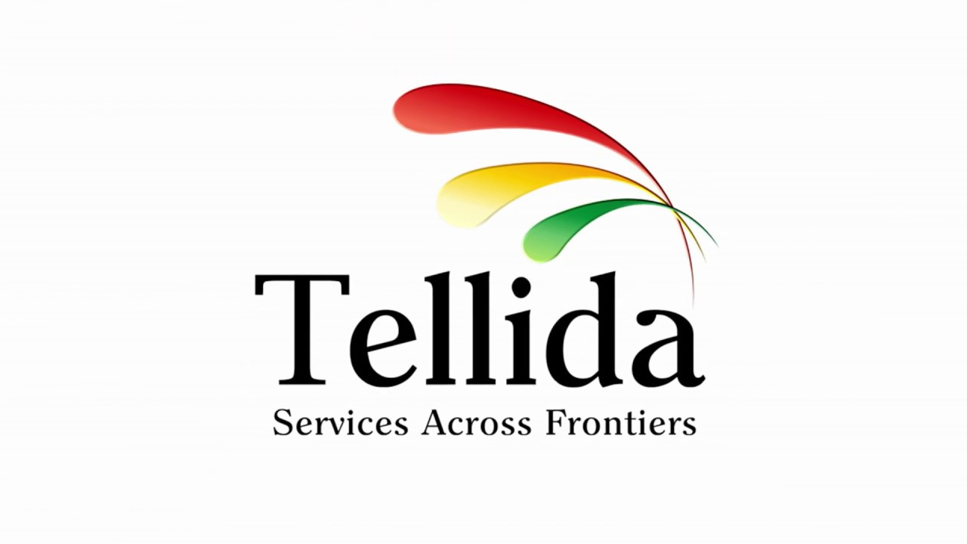

12/11/2021 9.00a.m. Conferrence Room

**A G E N D A**

Introduction

* 1. **Purpose** Review and evaluate the effectiveness of the management system.
  2. **Agenda** items and priorities
  3. **Recap**, Discussion on the status of any issues from the previous meeting

ISMS governance and management

* 1. Important organizational, business, or other changes affecting the ISMS, such as new laws, rules, or other compliance requirements
  2. Confirm the scope and objectives of the ISMS.
  3. Review the strategy, plans, roles, and responsibilities for information security.
  4. Resourcing for information security, including budgeting and returns on security investments
  5. Examine the performance and trends of the ISMS (security metrics)
  6. Policies on information security

Information risk management

* 1. Important information risks (threats, vulnerabilities, and repercussions), as well as opportunities, such as data security incidents affecting this or other businesses
  2. Information risk prioritization in comparison to other business risks (risk register)
  3. Risk management, which includes programs and efforts related to information security.Business continuity management
  4. Resilience, recovery and contingency plans, preparation and arrangements
  5. Continuity exercises – plans and results, improvements arising

ISMS continuous improvement

* 1. ISMS **internal** **audits** and management reviews – key findings, issues and plans
  2. Feedback from or concerning **external parties**
  3. Opportunities to **improve** the ISMS including preventative and corrective actions

Close

* 1. **Actions arising** from this meeting (with owners and due dates)
  2. **Resolutions** for executive management approval
  3. **Next *Management Review*** – date, venue, purpose, agenda items, invitees
  4. **Any other business**